Action to Focus and Accelerate Cell-based Tolerance-inducing Therapies
Europe's Biggest Research Network on CTT

Dear colleagues,
It is our pleasure to announce the A FACTT MC/WG meeting that will be held in Belgrade, Serbia on May 9,10th. Please find provisional schedule of the meeting below. There you can also find detailed data about our meeting place. It will be our great pleasure to meet you all in Belgrade.

Organizers
Dr Eva M MARTINEZ-CACERES
Chair of the Action
Dr Anja TEN BRINKE
Vice Chair of the Action

Local organizer
Dr Djordje MILJKOVIC
Institute for Biological Research “Sinisa Stankovic”
University of Belgrade
Schedule

May 9th
11:00-12:30 WG2 meeting
12:30-13:30 Lunch break
13:30-15:30 WG2 meeting (cont.)
15:30-16:00 Coffee break
16:00-17:30 MC meeting
19:00 Dinner
May 10th
9:00-12:30 WG3 meeting
12:30-13:30 Lunch break
13:30-15:30 WG1 meeting
15:30-16:00 Coffee break
16:00-17:30 WG1 meeting (cont.)

The meeting will be held at the Ceremony hall
University of Belgrade Rectorate
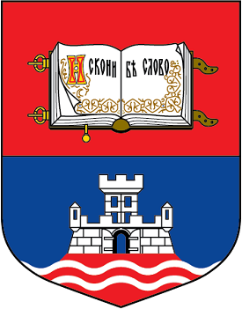
Studentski trg 1, Belgrade
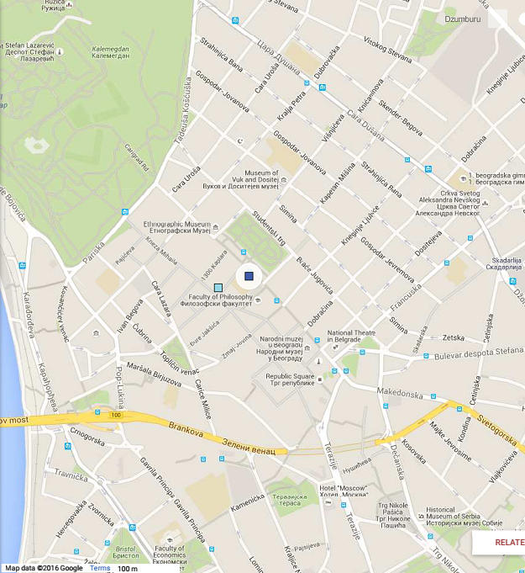
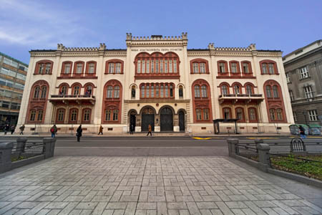

CITY CENTER

